Project Design Phase-II TechnologyStack(Architecture&Stack)

|  |  |
| --- | --- |
| Date | 03October2022 |
| Team ID | 592914-1698238643 |
| ProjectName | Project- Market Segmentation and Analysis using ML |
| MaximumMarks | 4Marks |

Technical Architecture:

A technical architecture for market segmentation refers to the design and structure of the technology stack used to implement, manage, and execute market segmentation strategies. The architecture should support data collection, analysis, and the delivery of tailored marketing efforts to different market segments.

Reference:<https://developer.ibm.com/patterns/ai-powered-backend-system-for-order-processing-during-pandemics/>

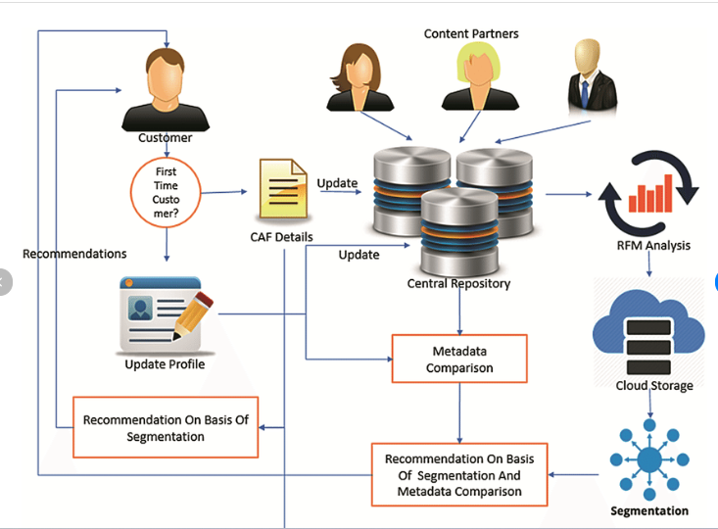

Table-1:Components& Technologies:

|  |  |  |  |
| --- | --- | --- | --- |
| **S.No** | **Component** | **Description** | **Technology** |
| 1. | UserInterface | allows users to input, analyze, and visualize data to identify distinct customer segments based on various criteria | HTML,CSS,JavaScript |
| 2. | Logic | The logic behind market segmentation is to tailor marketing efforts to these smaller segments to better meet their specific demands, preferences, and behaviors | Python |
| 7. | FileStorage | Filestoragerequirements | Hard Drives: Traditional mechanical hard drives (HDD) and modern solid-state drives (SSD) are common choices for local file storage on personal computers. They provide ample storage capacity and fast access times. |
| 8. | ExternalAPI-1 | Demographic Data APIs: APIs such as the U.S. Census Bureau API, Statista API, or social media platform APIs can provide demographic data that can be used to segment your market based on age, gender, location, income, and more. | IBMWeatherAPI, etc. |
| 10. | MachineLearningModel | Collect relevant data from various sources, including customer demographics, purchase history, website behavior, and any other relevant information. | Giving feed back analysis of customersetc. |

Table-2:ApplicationCharacteristics:

|  |  |  |  |
| --- | --- | --- | --- |
| **S.No** | **Characteristics** | **Description** | **Technology** |
| 1. | Open-SourceFrameworks | scikit-learn: scikit-learn is a popular machine learning library for Python. It provides various algorithms and tools for clustering and segmentation, including k-means, hierarchical clustering, DBSCAN, and Gaussian Mixture Models (GMM). It's a versatile choice for segmenting data. | Programming Language:python |
| 2. | SecurityImplementations | Encrypt sensitive data at rest and in transit. Use protocols like HTTPS, SSL/TLS for web traffic, and technologies like full-disk encryption for storage. | Python is used as a programming of datafor security implementation |
| 3. | ScalableArchitecture | Data Processing and Analysis | Python |
| 4 | Performance | Gather Historical Data: Collect and organize historical data related to the chosen performance metrics. This data can come from various sources, such as sales records, customer interactions, marketing campaigns, and website analytics | python |

References:

<https://neptune.ai/blog/customer-segmentation-using-machine-learning>

<https://towardsdatascience.com/customer-segmentation-with-machine-learning-a0ac8c3d4d84>